**A**

**Project Report on**

**“Breast Cancer Detection And Classification”**

SUBMITTED TO

**G H RAISONI COLLEGE OF ENGINEERING AND MANAGEMENT, WAGHOLI, PUNE**

**B. Tech in**

**Data Science**

# SUBMITTED BY

**Chaure Karina Bhanudas (2021DDSE1103081)**

**Deo Minal Kishor (2021DDSE1103092)**

**Patil Aditi Sunil (2021DDSE1103088)**

**UNDER THE GUIDANCE OF**

# Prof.Komal Jadhav



## DEPARTMENT OF DATA SCIENCE

**An Autonomous Institute, affiliated to Savitribai Phule Pune University Approved by AICTE, New Delhi and Recognized by Govt. Of Maharashtra NAAC Accredited**

**G H RAISONI COLLEGE OF ENGINEERING MANAGEMENT, WAGHOLI, PUNE.**

**2021-22**

# 

# CERTIFICATE

This is to certify that the project report entitles

**“Breast Cancer Detection And Classification”** submitted by

**Chaure Karina Bhanudas (2021DDSE1103081)**

**Deo Minal Kishor (2021DDSE1103092)**

**Patil Aditi Sunil (2021DDSE1103088)**

Has been submitted in partially fulfillment for the award of B-tech in data science engineering as per the curriculum laid by An Autonomous Institute, Affiliated to Savitribai Phule Pune University during the academic

|  |  |
| --- | --- |
| **(Prof. Komal Jadhav)** | **(Prof. Rachana Sable)** |
| **Project Guide** | **HOD** |

**(Prof. Dr. R. D. Kharadkar)**

**Principal**

**G H RAISONI COLLEGE OF ENGINEERING MANAGEMENT, WAGHOLI, PUNE.**

**PROJECT APPROVAL SHEET**

**This is to certify that dissertation report entitled “Breast Cancer Detection And Classification”by Ms. Chaure Karina Bhanudas, Ms. Deo Minal Kishor, Ms.Patil Aditi Sunil is accepted and approved in the fulfilment for the B-Tech in data science engineering.**

# SIGN OF EXAMINERS: -

INTERNAL:

EXTERNAL:

**ACKNOWLEDGEMENT**

We feel profound happiness in forwarding this project report as an image of sincere efforts.

The successful project reflects our work effort of our guide in giving us good information.

We sincere thanks to our guide **Prof.Komal jadhav** and H.O.D. respected **Prof.Rachna Sable** who has been a constant source of inspiration and guiding star in achieving our goal.

We express our deep gratitude to all staff members of Data Science department who laid us their valuable support and cooperation to enable us to complete our project successfully.

Goal makes us to do work. Vision is more important than goal which makes us to do work in the best way to make work equally the best. Thanks to Principal, **Prof.Dr. R. D. Khardkar** for his support and vision.

Name of Students

Chaure Karina Bhanudas (2021DDSE1103081)

Deo Minal Kishor (2021DDSE1103092)

Patil Aditi Sunil (2021DDSE1103088)

UNDER THE GUIDANCE OF Prof. Komal Jadhav DEPARTMENT OF Data Science an Autonomous Institute, affiliated to Savitribai Phule Pune University Approved by AICTE, New Delhi and Recognized by Govt. Of Maharashtra NAAC Accredited G H RAISONI COLLEGE OF ENGINEERING MANAGEMENT,

WAGHOLI, PUNE. 2021-22

## Abstract

Breast cancer is the most common cause of death in women and the second leading cause of cancer deaths worldwide. Primary prevention in the early stages of the disease becomes complex as the causes remain almost unknown. However, some typical signatures of this disease, such as masses and micro calcifications appearing on mammograms, can be used to improve early diagnostic techniques, which is critical for women’s quality of life. Xray mammography is the main test used for screening and early diagnosis, and its analysis and processing are the keys to improving breast cancer prognosis. As masses and benign glandular tissue typically appear with low contrast and often very blurred, several computer-aided diagnosis schemes have been developed to support radiologists and internists in their diagnosis. In this article, an approach is proposed to effectively analyze digital mammograms based on texture segmentation for the detection of early stage tumors. The proposed algorithm was tested over several images taken from the digital database for screening mammography for cancer research and diagnosis, and it was found to be suitable to distinguish masses and micro calcifications from the background tissue using morphological operators and then extract them through machine learning techniques and a clustering algorithm for intensity-based segmentation.

## Project mapping to COs and POS

|  |  |  |
| --- | --- | --- |
| **CO** | **CO Statements** | **Correlation** |
| **CO1** | Develop feature vectors for object detection purpose | **3** |
| **CO2** | Select algorithm for object recognition | **3** |
| **CO3** | Discuss image registration techniques | **1** |
| **CO4** | Discuss the concept of machine learning | **3** |
| **CO5** | Classify data/ signal using supervised classifiers | **3** |
| **CO6** | Classify data/ signal using unsupervised classifiers | **1** |

|  |  |  |
| --- | --- | --- |
| **PO** | **PO Statements** | **Correlation** |
| **PO1** | Engineering knowledge | **3** |
| **PO2** | Problem analysis | **3** |
| **PO3** | Design/development of solutions | **3** |
| **PO4** | Conduct investigations of complex problems | **2** |
| **PO5** | Modern tool usage | **3** |
| **PO6** | The engineer and society | **3** |
| **PO7** | Environment and sustainability | **3** |
| **PO8** | Ethics | **3** |
| **PO9** | Individual and team work | **3** |
| **PO10** | Communication | **2** |
| **PO11** | Project management and finance | **3** |
| **PO12** | Life-long learning | **3** |

Correlation Levels: - 1: Slight (Low) 2: Moderate (Medium) 3: Substantial (High)

## 1. Introduction

One in every eight deaths worldwide is caused by cancer. Cancer is the second leading cause of death in developed countries and the third leading cause of death in developing countries. In 2009, about 562 340 Americans died of cancer, more than 1500 people a day. Approximately 1 479 350 new cancer cases were diagnosed in 2009. In the United Sates, cancer is the second most common cause of death and accounts for nearly 1 in every 4 deaths [1]. Furthermore, breast cancer is the most common cause of death in women and the second leading cause of cancer deaths worldwide (after lung cancer) [2], and the chance of developing invasive breast cancer at some time in a woman’s life is about

1 in 8 (12.5 %) [3]. Approximately 182 000 new cases of breast cancer are diagnosed and 46 000 women die of breast cancer each year in the United States [4]. Until now, there is no effective way to prevent the occurrence of breast cancer. Therefore, as it is well known, early detection is the first crucial step towards breast cancer diagnosis and treatment. In terms of medical diagnosis and screening techniques, X-ray mammography is currently the most common technique used in clinical practice due to its low cost and accessibility. Although screening mammography presents some limitations, such as low reliability on dense breast of young women or women who underwent a surgical intervention, it has been recommended as the most effective method for early detection of breast cancer as it provides high sensitivity on fatty breast and excellent performance on micro calcification detection [5]. As a result, a large number of mammograms need to be examined by a limited number of radiologists, resulting in misdiagnoses due to human errors by visual fatigue. To improve the accuracy and efficiency of mammogram examination, computer aided diagnosis (CAD) has been introduced in the screening process to support radiologists and internists in their diagnosis. In general, CAD systems are used to support the interpretation of medical images and two main schemes can be found: computer aided detection (CADe) and computer-aided diagnosis (CADx); CADe is focused on the identification of the location of suspect regions while CADx is targeted to characterization (i.e., malignancy versus benignity) [2]. Currently, several image-processing methods for the detection of tumours in mammograms have been proposed. Various technologies such as fractal analysis [6], discrete wavelet transform, and Markov random field have been used. Li et al. [7] proposed a multiple circular path convolution neural network architecture that has been designed for the analysis of tumour and tumour-like structures, and Chan et al. [8] reported a two-stage adaptive density weighted contrast enhancement algorithm for tumour detection in mammograms. It is well known that the best prevention method is early detection, but primary prevention in early stages of the disease becomes complex as the causes remain almost unknown. Nevertheless, some typical signatures of this disease can be targeted such as masses and micro calcifications appearing on mammograms, which can be used to improve early diagnostic techniques. As a result, most of the previously mentioned techniques focused on two types of breast cancer: micro calcifications and masses.

In this study, a CADe scheme is proposed to effectively analyse digital mammograms based on texture segmentation for the detection of early stage tumours. The proposed algorithm was tested over several images taken from the digital database for screening mammography for cancer research and diagnosis, and it was found to be suitable to distinguish masses and micro calcifications from the background tissue using morphological operators and then extract them through machine learning techniques and the clustering algorithm for intensity-based segmentation.

Breast cancer (BC) is one of the most common cancers among women worldwide, representing the majority of new cancer cases and cancer-related deaths according to global statistics, making it a significant public health problem in today’s society.

The early diagnosis of BC can improve the prognosis and chance of survival significantly, as it can promote timely clinical treatment to patients. Further accurate classification of benign tumors can prevent patients undergoing unnecessary treatments. Thus, the correct diagnosis of BC and classification of patients into malignant or benign groups is the subject of much research. Because of its unique advantages in critical features detection from complex BC datasets, machine learning (ML) is widely recognized as the methodology of choice in BC pattern classification and forecast modelling.

Classification and data mining methods are an effective way to classify data. Especially in medical field, where those methods are widely used in diagnosis and analysis to make decisions.

**2. Objectives:**

The main purpose of a breast cancer is to separate suspicious regions that may contain masses from the background parenchyma (i.e., the characteristic tissue of an organ, which is distinguished from associated connective or supporting tissues) [3–7]. In other words, such schemes divide the mammogram into several non-intersecting regions and then extract regions of interest where suspicious mass candidates from the ultrasound image can probably be found. As explained in [2], architectural distortion, which produces alterations on the density, shape, and margins, is a reliable indicator of malignant changes, especially when it is manifested through visible lesions such as mass, asymmetry, or micro calcifications. Thus, image segmentation is essential to preserve the sensitivity and accuracy of the entire mass detection and classification system. The proposed technique is based on feature extraction through texture analysis for the identification and discrimination of suspicious areas related to cancer and benign tumours, as well as micro calcifications. As texture-based analysis methods characterize texture in terms of the extracted features, segmentation depends not only on the images under study but also on the aim for which the image texture analysis is used [6]. The performance of various methods reported in the literature has been measured on different data sets, and it has also been demonstrated that the database by itself significantly influences the performance of the algorithms [5]. The proposed algorithm deals with data extracted from eight-bit grey scale images obtained from the digital database for screening mammography (DDSM) [9, 10]. Abnormalities in the breast tissue, whether benign or malign, are typically found in the form of clusters of cells, which in the image means that abnormalities are represented by regions with their own properties and, in an early stage of the examination, these areas are just slightly different from the rest of the image. These texture and morphological differences in the abnormality region allow identification, analysis, discrimination, and extraction of the abnormal region. Nevertheless, such abnormal regions are not always clear to the naked eye and the aid of a more powerful tool is highly convenient. Once it has been segmented, an image can be represented in two different ways: external and internal. External representation is used when desired shape characteristics are to be highlighted while internal representation is useful to focus on regional properties (i.e., texture values) [11]. This impliesthat we are mainly focused on the internal representation, as our purpose is the separation (extraction) of the objects of interest from the background based on texture segmentation values (abnormalities). Entropy, which is, in general, a statistical measure of randomness, was first defined to be used in image processing by Pun, in 1980 [14]. Despite several proposals to consider both high-order histograms and entropies of new images generated from the properties of the original input image to obtain additional information [15], the proposed algorithm only considers the first-order entropy, which makes it easier to implement and computationally cost effective. In this particular case, we have drawn on the local entropy as the first stage of the proposed algorithm. Unlike the entropy proposed by Pun, the local entropy is defined for a small region Ωk by a window size (Mk × Nk) within the input image, as follows: [11,13]

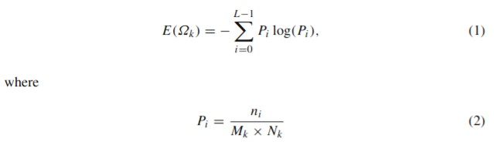

This analysis aims to observe which features are most helpful in predicting malignant or benign cancer and to see general trends that may aid us in model selection and hyperactive parameter selection. The goal is to classify whether the breast cancer is benign or malignant. To achieve this the algorithm have used machine learning classification methods to fit a function that can predict the discrete class of new input.

### 3. Methodology

The features from the data set describe characteristics of the cell nuclei and are computed from a digitized image of a fine needle aspirate (FNA) of a breast mass. As described in [UCI Machine Learning Repository,](https://archive.ics.uci.edu/ml/datasets/Breast+Cancer+Wisconsin+%28Diagnostic%29) the attribute information’s are:

1. ID number
2. Diagnosis (M = malignant, B = benign)
3. 32 Ten real-valued features are computed for each cell nucleus:
4. radius (mean of distances from centre to points on the perimeter)
5. texture (standard deviation of gray-scale values)
6. perimeter
7. area
8. smoothness (local variation in radius lengths)
9. compactness (perimeter^2 / area - 1.0)
10. concavity (severity of concave portions of the contour)
11. concave points (number of concave portions of the contour)
12. symmetry
13. fractal dimension ("coastline approximation" - 1)

The mean, standard error and "worst" or largest (mean of the three largest values) of these features were computed for each image, resulting in 30 features. For instance, field 3 is Mean Radius, field 13 is Radius SE, field 23 is Worst Radius.

Not all parameters of a classifier is learned from the estimators. Those parameters are called hyper-parameters and are passed as arguments to the constructor of the classifier. Each estimator has a different set of hyper-parameters, which can be found in the corresponding documentation.

So search for the best performance of the classifier sampling different hyperparameter combinations. This will be done with an [exhaustive grid search,](http://scikit-learn.org/stable/modules/grid_search.html#grid-search) provided by the GridSearchCV function. The grid search will be done only on the best models, which are *Logistic Regression, Random Forest and Decision Trees.*

* 1. *Logistic Regression:*

Logistic regression is a supervised learning classification algorithm used to predict the probability of a target variable. The nature of target or dependent variable is dichotomous, which means there would be only two possible classes.

In simple words, the dependent variable is binary in nature having data coded as either 1 (stands for success/yes) or 0 (stands for failure/no).

Mathematically, a logistic regression model predicts P(Y=1) as a function of X. It is one of the simplest ML algorithms that can be used for various classification problems such as spam detection, Diabetes prediction, cancer detection etc.

* 1. *Random Forest:*

Random forest is a supervised learning algorithm which is used for both classification as well as regression. But however, it is mainly used for classification problems. As we know that a forest is made up of trees and more trees means forest that is more robust. Similarly, random forest algorithm creates decision trees on data samples, then gets the prediction from each of them, and finally selects the best solution by means of voting. It is an ensemble method, which is better than a single decision tree because it reduces the over-fitting by averaging the result.

Working of Random Forest Algorithm:

We can understand the working of Random Forest algorithm with the help of following steps −

* + - **Step 1** − First, start with the selection of random samples from a given dataset.
    - **Step 2** − Next, this algorithm will construct a decision tree for every sample. Then it will get the prediction result from every decision tree.
    - **Step 3** − In this step, voting will be performed for every predicted result.
    - **Step 4** − At last, select the most voted prediction result as the final prediction result. The following diagram will illustrate its working –

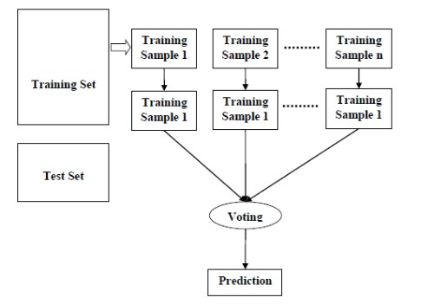

Fig 1: Random Forest Algorithm

*3.2 Decision Trees:*

In general, Decision tree analysis is a predictive modelling tool that can be applied across many areas. Decision trees can be constructed by an algorithmic approach that can split the dataset in different ways based on different conditions. Decisions trees are the most powerful algorithms that falls under the category of supervised algorithms.

They can be used for both classification and regression tasks. The two main entities of a tree are decision nodes, where the data is split and leaves, where we got outcome. The example of a binary tree for predicting whether a person is fit or unfit providing various information like age, eating habits and exercise habits, is given below −

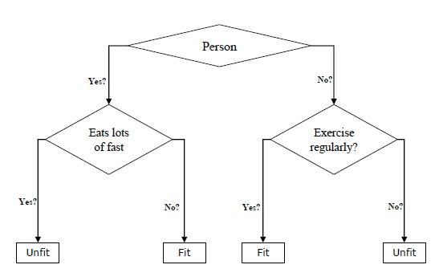

Fig 2: Decision Tree Algorithm

In the above decision tree, the question are decision nodes and final outcomes are leaves. We have the following two types of decision trees.

* **Classification decision trees** − In this kind of decision trees, the decision variable is categorical. The above decision tree is an example of classification decision tree.
* **Regression decision trees** − In this kind of decision trees, the decision variable is continuous.

### 4. Algorithm

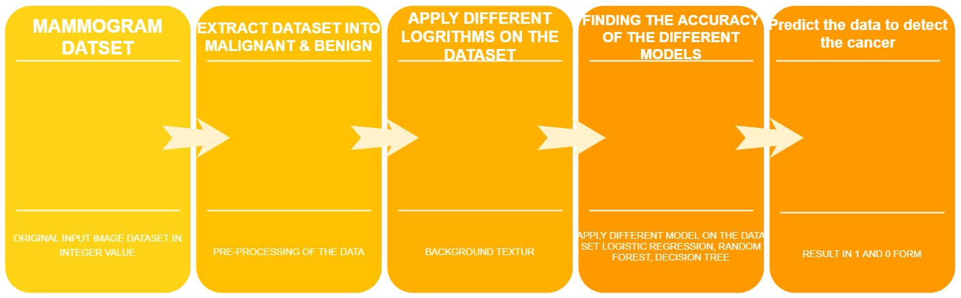

Fig. 3 General schematic of the proposed algorithm

### 5. Data Base description

The features from the data set describe characteristics of the cell nuclei and are computed from a digitized image of a fine needle aspirate (FNA) of a breast mass. As described in [UCI Machine Learning Repository,](https://archive.ics.uci.edu/ml/datasets/Breast+Cancer+Wisconsin+%28Diagnostic%29) the attribute information’s are:

1. ID number
2. Diagnosis (M = malignant, B = benign)
3. 32 Ten real-valued features are computed for each cell nucleus:

* a) radius (mean of distances from centre to points on the perimeter)
* b) texture (standard deviation of gray-scale values)
* c) perimeter
* d) area
* e) smoothness (local variation in radius lengths)
* f) compactness (perimeter^2 / area - 1.0)
* g) concavity (severity of concave portions of the contour)
* h) concave points (number of concave portions of the contour)
* i) symmetry
* j) fractal dimension ("coastline approximation" - 1)

The mean, standard error and "worst" or largest (mean of the three largest values) of these features were computed for each image, resulting in 30 features. For instance, field 3 is Mean Radius, field 13 is Radius SE, and field 23 is Worst Radius.

### 6. System Implementation

Start by loading packages that will help us organize and visualize the data. Then build visualizations of the data in order to decide how to proceed with the machine learning tools. To do that, we will need to use the [Seaborn](https://seaborn.pydata.org/) and the [Matplotlib](https://matplotlib.org/) packages.

We are interested mainly in the mean values of the features, so we will separate those features in the list below in order to make some work easier and the code more readably.

It is also possible to create a scatter matrix with the features. The red dots correspond to malignant diagnosis and blue to benign. Look how in some cases reds and blues dots occupies different regions of the plots.

**Encode the categorical data**. Change the values in the column ‘*diagnosis’* from **M and B** to **1 and 0** respectively, then print the results.

**Create a pair plot**. A “pairs plot” is also known as a scatter plot, in which one variable in the same data row is matched with another variable’s value.

**Split the data** again, but this time into 75% training and 25% testing data sets.

**Scale the data** to bring all features to the same level of magnitude, which means the feature / independent data will be within a specific range for example 0–100 or 0–1.

**Create a function** to hold many different models (e.g. *Logistic Regression*, *Decision Tree Classifier*, *Random Forest Classifier*) to make the classification. These are the models that will detect if a patient has cancer or not. Within this function I will also print the accuracy of each model on the training data.

**Create the model** that contains all of the models, and look at the accuracy score on the training data for each model to classify if a patient has cancer or not.

**Show the confusion matrix and the accuracy** of the models on the test data. The [confusion matrix](https://en.wikipedia.org/wiki/Confusion_matrix) tells us how many patients each model misdiagnosed (number of patients with cancer that were misdiagnosed as not having cancer a.k.a **false negative**, and the number of patients who did not have cancer that were misdiagnosed with having cancer a.k.a **false positive**) and the number of correct diagnosis, the **true positives** and **true negatives**.

1. ***False Positive (FP)*** *= A test result which incorrectly indicates that a particular condition or attribute is present.*
2. ***True Positive (TP)*** *= Sensitivity (also called the* ***true positive*** *rate, or probability of detection in some fields) measures the proportion of actual positives that are correctly identified as such.*
3. ***True Negative (TN)*** *=* ***Specificity*** *(also called the* ***true negative*** *rate) measures the proportion of actual* ***negatives*** *that are correctly identified as such.*
4. ***False Negative (FN)*** *= A test result that indicates that a condition does not hold, while in fact it does. For example a test result that indicates a person does not have cancer when the person actually does have it*

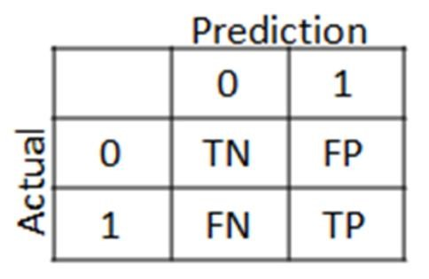

Fig. 4 Confusion Matrix

### 7. Results

From the accuracy and metrics above, the model that performed the best on the test data was the Random Forest Classifier with an accuracy score of about **96.5%.** So the model to detect cancer cells in patients. Make the prediction/classification on the test data and show both the Random Forest Classifier model classification/prediction and the actual values of the patient that shows rather or not they have cancer.

It is notice that model, misdiagnosed a few patients as having cancer when they didn’t and it misdiagnosed patients that did have cancer as not having cancer. Although this model is good, when dealing with the lives of others I want this model to be better and get its accuracy as close to 100% as possible or at least as good as if not better than doctors. Therefore, a little more tuning of each of the models is necessary.

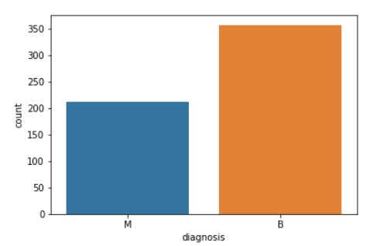

Fig 5: Chart Displaying Malignant (Cancerous) & Benign (Non-Cancerous) Diagnosis

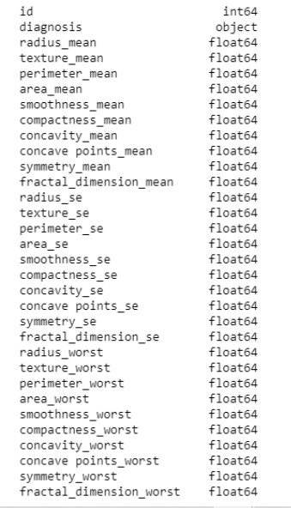

Fig 6: A list of the columns & their data types

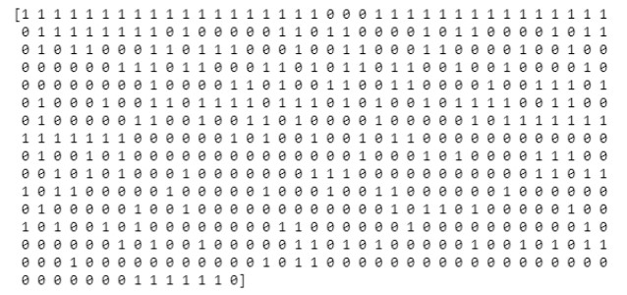

Fig 7: The encoded values of the feature/column diagnosis

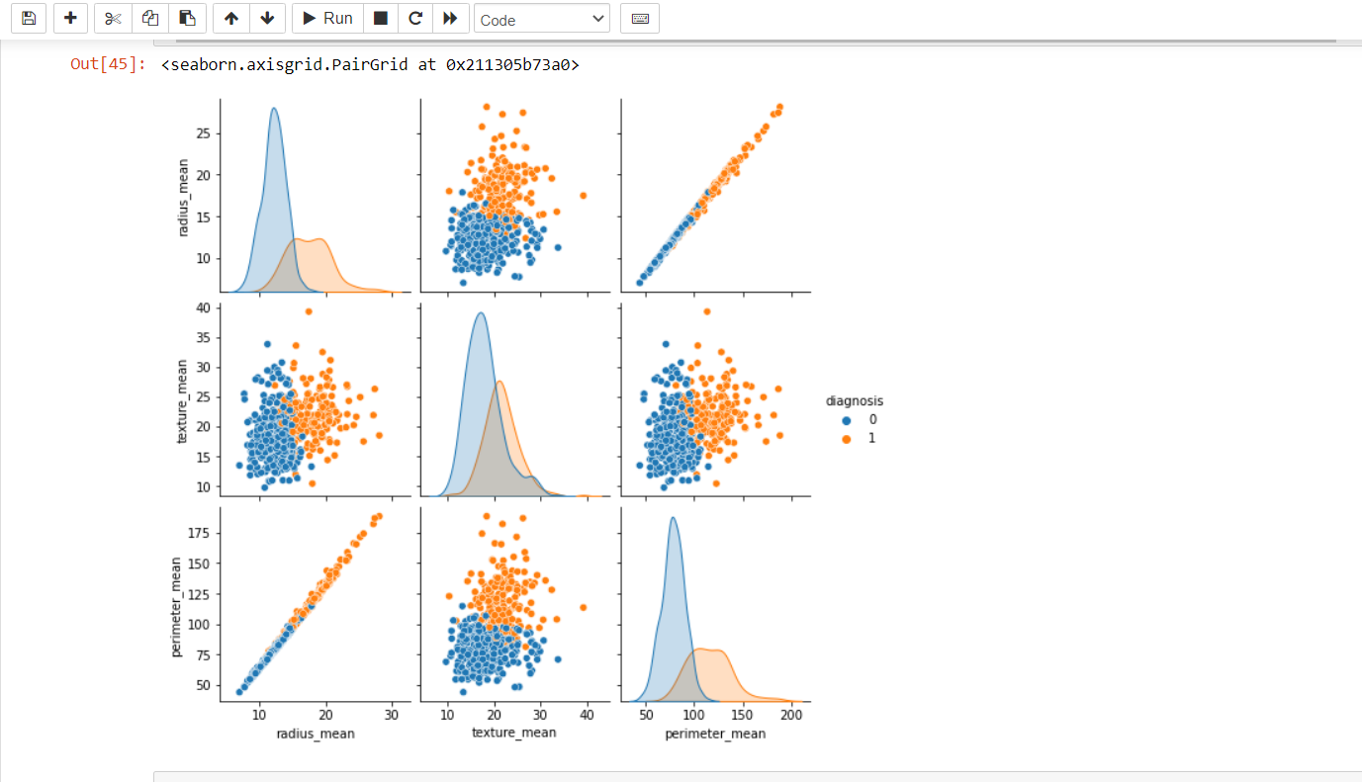

Fig 8: Pair plot of all of the columns highlighting the diagnosis points in Orange (1) & Blue (0)

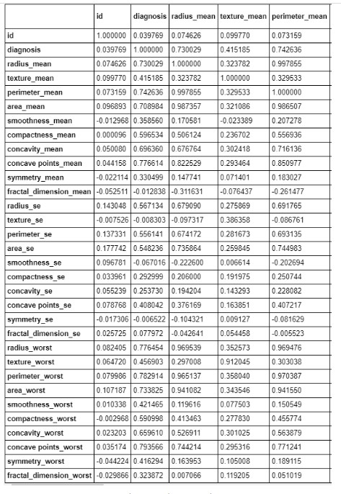

Fig 9: Column correlation sample

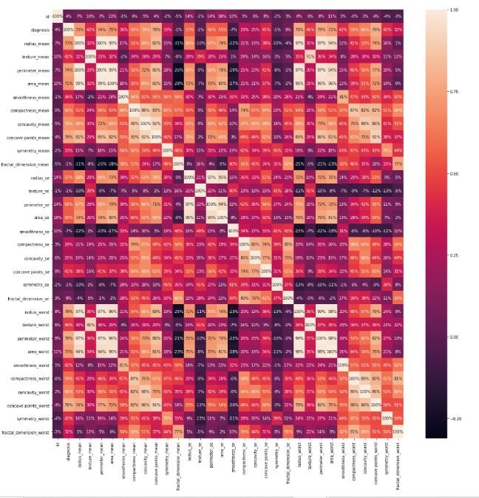

Fig 10: Heat map of correlations

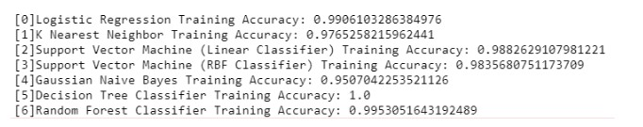

Fig 11: The accuracy of each model on the training data

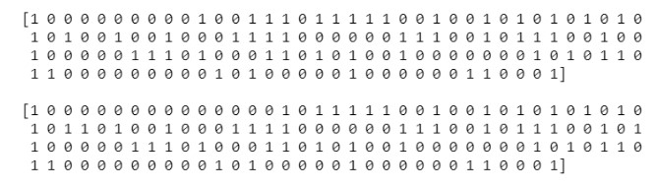

Fig 12: **Top:** Decision Tree Classifier prediction, **Bottom:** The actual classification of the patients

## 8. Applications

* It can used to predict the Breast Cancer
* It can be used to classify the Breast Cancer

## 9. Conclusion

Breast cancer is the most common cancer in women and the second main cause of cancer death in women. When the early symptoms of breast cancer are ignored, the patient might end up with drastic consequences in her health and can lead to death. Breast cancer can be kept under control when it is detected early. Many studies focus mainly on the application of classification techniques to breast cancer prediction; rather than studying various home data cleaning and pruning techniques that can prepare and make a dataset suitable for mining. It has been observed that a good dataset provides better accuracy. Selection of appropriate algorithms with good home dataset will lead to the development of prediction systems. These systems can assist in proper treatment methods for a patient diagnosed with breast cancer. There are many treatments for a patient based on breast cancer stage; data mining and machine learning can be a very good help in deciding the line of treatment to be followed by extracting knowledge from such suitable databases.

**10. References:**

1. M. Garcia, A. Jemal, E. Ward, M. Center, Y. Hao, R. Siegel, M. Thun, Global, Cancer Facts & Figures (American Cancer Society, Atlanta, GA, 2007)
2. T.M. Deserno (ed.), Biomedical Image Processing (Springer, Berlin, 2010)
3. http://www.breastcancer.org, Breast Cancer Statistics (2009)
4. H.D. Cheng, X. Cai, X. Chen, L. Hu, X. Lou, Pattern Recognit. 36, 2967 (2003)
5. M.J. Bottema, G.N. Lee, S. Lu, Automatic image feature extraction for diagnosis and prognosis of breast cancer, in Artificial Intelligence Techniques in Breast Cancer Diagnosis and Prognosis, Series in Machine Perception and Artificial Intelligence, vol 39 (World Scientific Publishing Co. Pte. Ltd., Singapore, 2000), pp.

17–54

1. L. Zheng, A.K. Chan, IEEE Trans. Med. Imaging 20, 559 (2001)
2. H. Li, B.L. Shih-Chung, Y. Wang, L. Kinnand, M.T. Freedman, IEEE Trans. Med. Imaging 21, 139 (2002)
3. H.P. Chan, N. Petrick, B. Sahiner, Computer-aided breast cancer diagnosis, in Artificial Intelligence Techniques in Breast Cancer Diagnosis and Prognosis, Series in Machine Perception and Artificial Intelligence, vol 39 (World Scientific Publishing Co. Pte. Ltd., Singapore, 2000), pp. 179–264
4. M. Heath, K. Bowyer, D. Kopans, R. Moore, W.P. Kegelmeyer, The digital database for screening mammography, in Proceedings of the Fifth International Workshop on Digital Mammography, ed. by M.J. Yaffe (Medical Physics Publishing, Madison, Wisconsin, 2001), pp. 212–218
5. M. Heath, K. Bowyer, D. Kopans, W.P. Kegelmeyer, R. Moore, K. Chang, S. Munish Kumaran, Current status of the digital database for screening mammography digital mammography, in Proceedings of the Fourth International Workshop on Digital Mammography (Kluwer Academic Publishers, Dordrecht, The Netherlands, 1998), pp. 457–460
6. R.C. Gonzalez, R.E. Woods, S.L. Eddins, in Digital Image Processing Using MATLAB (Pearson Prentice

Hall, Upper Saddle River, NJ, 2003), chap. 11

1. J.J. Gerbrands, Segmentation of noisy images, Ph.D. Dissertation, Delft University, The Netherlands, 1988
2. C. Yan, N. Sang, T. Zhang, Pattern Recognit. Lett. 24, 2935 (2003)
3. T. Pun, Signal Process. 2, 223 (1980)
4. Ch. Thum, Opt. Acta Int. J. Opt. 31, 203 (1984)
5. P. Soille, in Morphological Image Analysis: Principles and Applications (Springer, New York, 1999), pp. 164–165
6. L. Vincent, Morphological grayscale reconstruction in image analysis: applications and efficient algorithms. IEEE Trans. Image Process. 2, 176 (1993)
7. S.S. Basha, K.S. Prasad, Int. J. Comput. Sci. Netw. Secur. 8, 211 (2008)
8. S.S. Basha, K.S. Prasad, Morphological image processing in bio-medical application, in Proceedings of PCEAI-FTOMM- International Conference (PICA, Nagpur, 2006; Bio-Medical Engineering NCBME, Mumbai, 2006)